Special Trip to the „Greening the Desert“ Project (Insert Date Here)

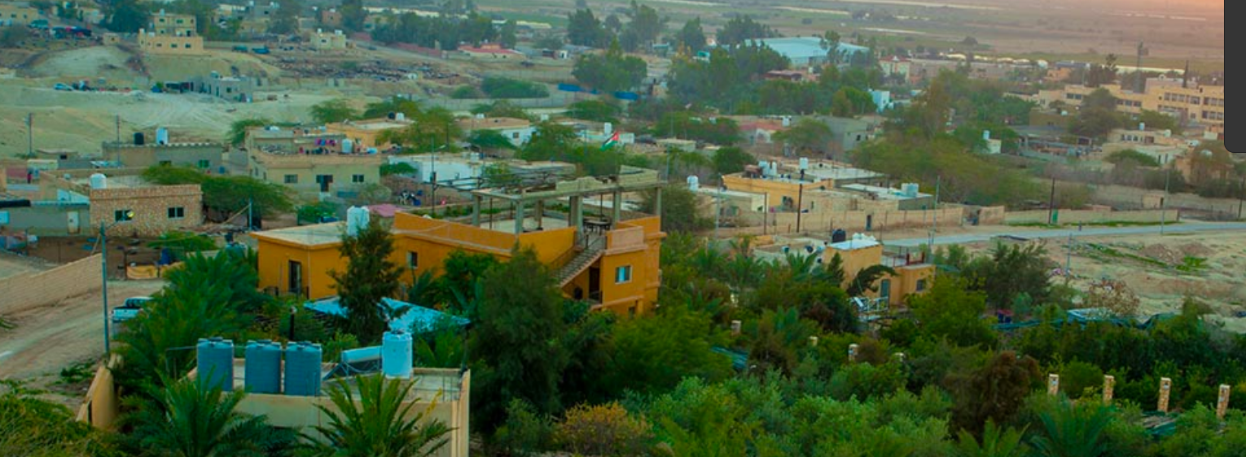
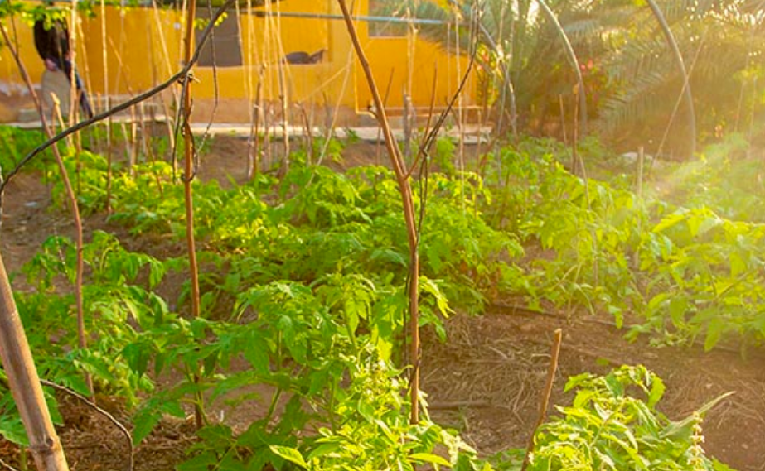

- Deadline to sign up: Sunday: 26 November 2021
- Seats are limited; we only have X seats (FIRST COME … FIRST SERVE)
- Please inform me if you are willing to participate and reserve a seat by giving me the fees in advance.
Fees are refundable if you cannot join for any urgent reason, but you must inform me 48 Hours before the trip day (Wednesday, X November)
- Meeting point: 7th Circle, inside C-Town parking area
- Meeting time: the buses will leave sharply at 08:00 am
- Program of the trip:
- (From 9:30 am to 11:30 am): We will arrive at ...
- (From 11:30 pm to 1:00 pm): We will ...
- (From 1:00 pm to 2:00 pm): We will …
- (From 2:00 pm to 3:00 pm): We will ...
- Total Cost: 7 JOD (to be paid in advance at my office or on the trip day for SABE students):
  - Transportation
  - Donation to the Permaculture Project.
  - Lunch, Water, Soft Drinks, Kinafa (‫)كنافه‬, Tea & Coffee
- Reminders:
  - Please bring some food & drinks for the morning and wear warm clothes because it will be cold in the evening.
  - Do not forget to bring your Student ID Card and wear your mask.

